Project 1: Line of Best Fit
In this project you will:
- Use array mathematics to calculate the line of best fit through data
- Plot the data and the line on a graph
- Plot two sets of data against each other

The ‘best fit straight line’ through N data points (x_{i},y_{i}) has a gradient (i.e. a slope) m and intercept c given by the formulae

and

where and are arithmetic means (averages) given by

and

Suggestions for the design of the VI to implement these calculations and to display the results:
  - You enter the x and y data in arrays on the front panel
  - The average values of the two arrays are calculated using a subVI
  - The values of the gradient is calculated using a subVI
  - The value of the intercept is calculated
  - An XY graph is created which displays the data points and the best fit line

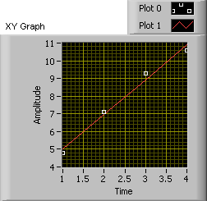
To test your VI you could use the data below:
x (seconds) | y (metres)
1.0 | 4.8
2.0 | 7.1
3.0 | 9.3
4.0 | 10.6

Average x = 2.50
Average y = 7.95
Slope = 1.96
Intercept = 3.05

There are MANY ways to extend this project further…
- Load data from a file
- Fit curves as well as straight lines
- Include calculation of the error of the slope and gradient
- Include y-error bars on the data points and consider them in the calculations (see file on NOW for help on doing this)

Project 2: Image Processing
In this project you will:
- Load images and display them in a VI
- Use controls to adjust the brightness and contrast of the image

An image is really nothing more than a 2D array of data. The value of every element in the array corresponds to the brightness of the image at that point.
In this project you will create a VI which loads a 2D array of data and then displays it on the screen using the Intensity Graph. Three example files (boats.txt, gordon.txt and parrot.txt) are available on the module webpage that you can use. However, you can also use any other black and white image you like, but will need to convert it to a “text image” first. To do this you can use some software called “ImageJ” which is available on the computers and is free to download.

You can vary the brightness of an image by adding the same value to every element in the array.
The contrast of an image is adjusted by multiplying every element in the array by the same value. Using numerical controls and simple array mathematics, you should adjust the brightness and contrast of your displayed image.

Some other ideas that you could try with image manipulation are:
  - Invert an image (change black to white and white to black)
  - Merging two images together
  - Rotate an image by 90 degrees (or an arbitrary amount, much harder!)
  - Smudge the image (by replacing the actual value by the average of the neighbouring elements)
  - Add random noise to each pixel of the image
  - Zoom into the image
  - Distort the image, possibly like gravitational lensing…

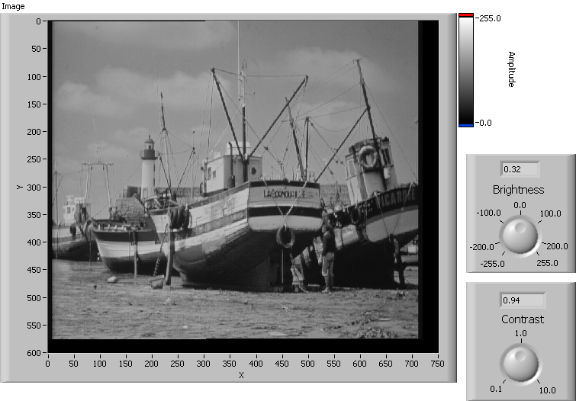

Project 3: Sorting an Array
In this project you will:
- Use the sorting subVI from exercise 5
- Implement a ‘Bubble Sort’ algorithm to sort an array of any size

The subVI you created in Exercise 5 was used to sort 2 numbers. This same swap function will be used in this project to sort an array of data using a process called bubble sort. The bubble sort algorithm works its way along through the elements of an array, comparing adjacent elements, and if the first element is smaller than the second, swapping them over. When the swap reaches the end of the array, it goes back to the beginning and repeats until everything is in order, a maximum of N-1 times.

You may want to start by sorting 2 numbers, then 3, then 4 - this might help you see any patterns.

To create a bubble sort VI, you will need to use two for loops, both with shift registers. You will need to think quite carefully about how to wire up the various components, and may need to write down pseudocode. Feel free to look on the internet or in books for help.

Once you have the bubble sort VI working, add a graph, such as a waveform chart, to display the values as they get sorted. You could use a for loop to generate a large array (say 1000 values) with random values and watch them getting sorted, as shown below:

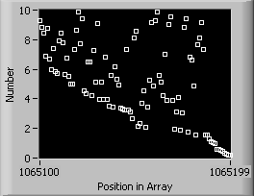
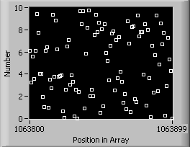
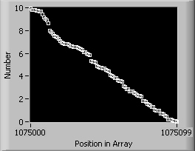

You can then have a race – use a clock to see how fast your sorting algorithm is. How does the time depend on the number of values. If you double the number, does the time also double?

The bubble sort algorithm is one of many ways of sorting a list of numbers, in fact, it is not a particularly efficient method! One alternative method is called an insertion sort. If you have time, research this method and implement it in a VI. How much faster is this?

Project 4: Reaction Timer
In this project you will:
- Design a reaction timer VI
- Calculate average reaction times
- Display the data on a graph

The reaction time is the time it takes you to perform a simple task after being given a stimulus. In this project you will design your own “stimulus”, probably a visual message that appears on the screen (try using the one or two button dialogs) a random time interval after the VI starts. Using a sequence structure (which we have not previously covered) you will then measure the time in seconds for the user to respond to this message.

Once you have succeeded in creating this VI, you can place the entire VI in a loop allowing repeated measurements to be made. You can then use the collected data to determine fastest and slowest and average reaction time, and also to present the data on a graph.

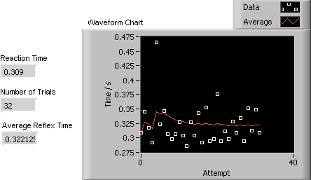

Adapt the reaction test, so that the user needs to make a decision between two choices depending on the message that is presented.

How can you develop the program? Here’s a few suggestions: how about a maths quiz with random questions? Or a leader board to show who has been the fastest so far? How about a ‘league table’?

Project 5: Animated Figures
In this project you will:
- Create animated curves
- Display moving waves, interference…
- …or create the solar system!

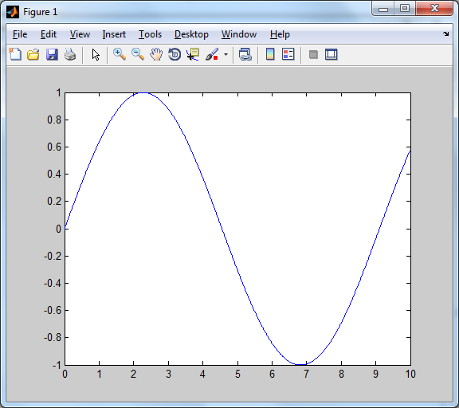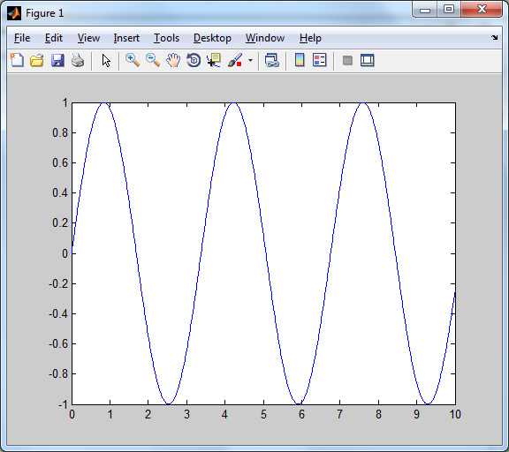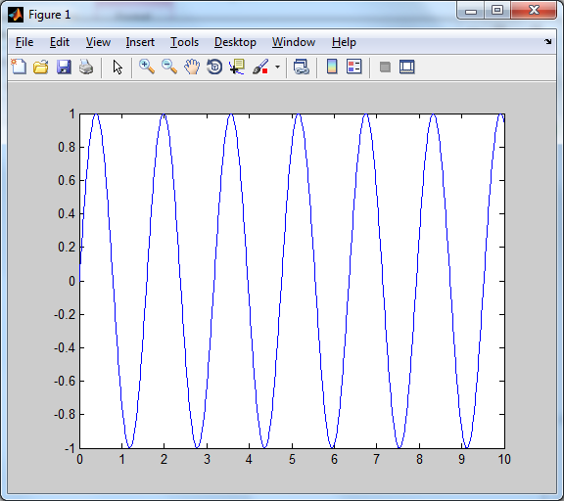

Although you have only used matlab to create static curves, it is straightforward to animate them too, using a simple loop, for example:

close all % close any existing graphs

set(gcf,'doublebuffer','on') % makes the animation smoother

x = 0:0.01:10;

for a = 0:0.03:10
plot(x,sin(a*x))
axis([0 10 -1 1])
pause(0.03)
end

Investigate animating your own graphs – be creative!
- You could create a travelling wave, and then create standing waves with different travelling in opposite directions.
- You could also try to create 3d graphs that varied in time – perhaps a circular wave spreading out from a point, or other mathematical functions
- Or you could create a model solar-system! Plot a point in the centre for the Sun and a point further out for the Earth. Update the position of the Earth over time. Add other planets and moons too, as shown below. Or even in 3D…

Once you’ve got your animation, what can you do with it? Here are a few features you can add:
- How can you save the data? What formats would be useful to the user?
- How can you analyse the data? For example, if you’ve been thinking about electromagnetic wave, could your program draw some of the related quantities, like the Poynting vector, as well as the wave?
- What about some other quantities? How about some time-average quantities – power, for example? Or orbital period? How about the eccentricity of the orbit – could you show it on the graph? Be creative!

Project 6: Toads and Frogs
In this project you will:
- Implement the classic game of Toads and Frogs
- Create an interface that allows shows the game being played
- Develop and analyse the program – for example, how many ways can each game be played? What rules can be added to change the way that the game is played?

Toads and Frogs is an example of a combinatorial game. The game starts with a straightforward idea: a group of frogs occupy the leftmost positions on a 1D grid, and the toads are on the right. There can be different numbers of frogs and toads and they can be separated by a single empty space. If you don't like thinking about amphibians or if you want to play the game yourself, you can think about/use coins instead – either face up or down, but in any version of the game the ‘creatures’ that start on the left can only move to the right, and those that start on the right can only move to the left. Each player has then two ‘legal’ moves:

- You can push a frog one place to the right, or a toad one place to the left, as long as there is an empty space for the frog or toad to move into.
- The frog or toad can jump over an adjacent frog or toad, into an empty space

The ‘winner’ is the one who gets either all their frogs over to the right hand, or their toads all over to the left, and a ‘loser’ is one who cannot make any moves.
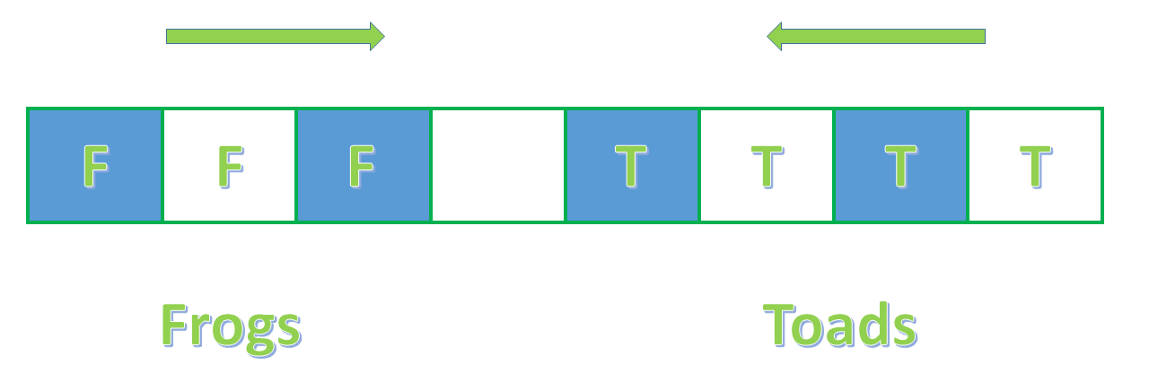
What can we investigate?

- How many moves are needed to completed the game? How does changing the numbers of frogs or toads, or the number of spaces separating them, affect this number?
- Can the computer show the user the game being played? Can the program be changed so the computer can actually play the user, or so that two users can play each other?
- Can we add new rules – for example, if a frog or a toad can’t move, can it be ‘killed’ and removed from the game? What happens if we ‘apply’ this rule every 5 turns – or every 10? Does it make the game easier to win, and for whom?

Project 7: Modelling of an ideal gas
In this project you will:
- Model atomic particles
- Use collision detection
- Implement collision rules
- Understand optimisation

Computer modelling is becoming increasingly common for solving problems much faster and on a larger scale than can be done by hand, for example looking at the evolution of a system of many particles such as an ideal gas. In this project model you will model the behaviour of an ideal gas inside a box in which the particles collide with the walls and each other. Recommended resource for learning about collision detection and response is: “Physics for Game Developers – David M. Bourg, Cambridge Press, 2002”.

You may implement this task in C, Matlab, Labview or a combination of these but it would be advantageous if you could display the particle positions on the screen, and show how they move.

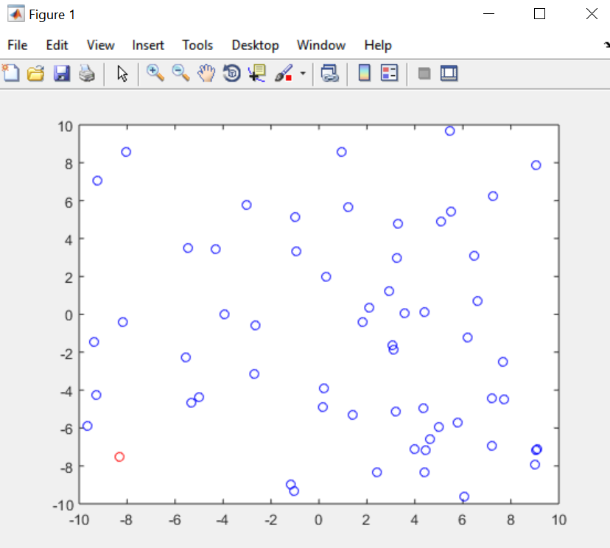

To further extend this project you could:
- Optimise your code to handle large numbers of particles quickly (and run tests to see how changes affect the speed)
- How can you calculate the physical quantities of the gas? What about the mean kinetic energy? How about including a temperature dependence, or a range of speeds for the gases – how about a Maxwell Boltzmann distribution? What about the other quantities of the gas, such as the speed of sound – could the computer calculate them – and present them appropriately – on a graph, or a histogram, or just a number?
- If you started with a 2D gas, can you expand the simulation to 3D?
- Can you record the positions to play back as a video?

Project 8: Projectile Motion
In this project you will:
- Model the behaviour of a projectile under the influence of gravity
- Plot 2D dynamic figures

The parabolic motion of an object under the force of gravity should be a very familiar concept. Your task is to model the behaviour of a projectile under the influence of gravity when launched from a stationary position with a given velocity (v) at a given angle (θ).

Your program should:
- Allow the user to set an initial angle and velocity
- Have the object accelerated due to gravity and stop simulating once the object has hit the ground
- Display the motion graphically to the user
- Provide feedback/data such as total distance travelled/maximum height reached

You may implement this task in C, Matlab, Labview or a combination of these but your project MUST be able to display positions to run a real time simulation

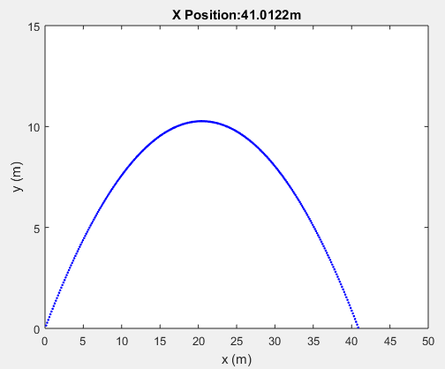

To further extend this project you could:
- Implement a collision detection algorithm and objects into the simulation acting as targets
- Replace the initial launch speed with a calculation relating the applied force and spring constant in a catapult type system
- If you started with a 2D simulation, could you expand the simulation to 3D?
- Add external forces such as wind/drag

Project 9: Random Walks and Brownian Motion
In this project you will:
- Simulated random walk
- Plot these random walks in 2D and 3D
- Calculate their statistical properties

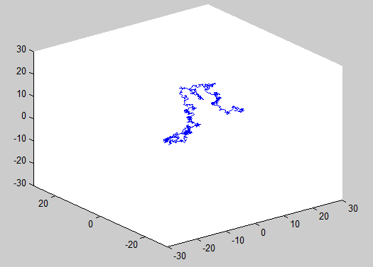

Random walks are important in various areas of physics and mathematics, and are a convenient way of modelling physical effects such as the diffusion of gases through a material, and the flow of electric current through a conductor. They are simple to create: imagine tossing a coin, and taking a step left for heads and right for tails. Then repeat this many times…the path you create is called a random walk. You can imagine asking questions about the properties of this walk: how far away from the start will you be at the end? How many times will you come back on yourself? What happens if the walk if in 2D rather than just left and right? What about in 3D with up, down, left, right, forward and backwards, and all the other directions in between?

In this project you will simulate a physical system using random walks to describe the motion of the particles in the system. You will need to simulate the motion of many particles together and then analyse and ideally visualise their motion.

What quantities can you analyse? How about:
- The average length of each path
- What about adding a bias to the walk? This is like adding an electrical potential to each end of a conductor – this potential then creates an electrical current through the conductor
- What about two opposing flows of particles? How often do they collide? How quickly do they diffuse?

Think about the most appropriate ways of presenting these analysed quantities as well. Should they appear as graphs, or histograms? Can they be controlled? For example, can the diffusion rate be changes if more particles are used, or less? See what you can find out!

Project 10: Advanced Pendulum Simulation
In this project you will:
- Look at phase portraits of the pendulum
- Visualise the swinging pendulum
- Add damping to the pendulum

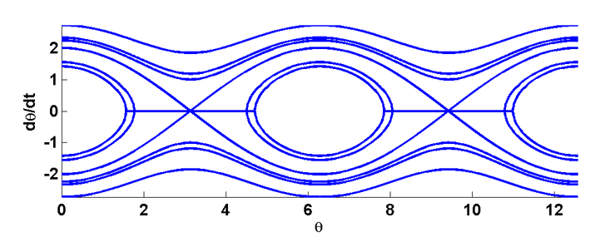

The pendulum program you made earlier in the year plotted angle against time. There are many further additions you can investigate:

- Visualise the swinging pendulum so that you can actually see its motion.
- Create “phase portraits” where the angle is plotted against velocity instead, as shown above.
- Add damping to see how the pendulum amplitude will slowly decay
- Add a forcing term, like pushing a swing, to see how the pendulum responds

To visualise the pendulum you will need a new graph in which you plot the position of the end of the pendulum at one instance. You will need to calculate this position from the known pendulum length and the angle. As the calculation proceeds, you should re-plot the graph to show the swinging motion. By changing the graph properties, you can make it look like a pendulum rather than just a dot on a graph too.

To create phase portraits you will need to keep a track of angle and velocity values. As it stands, the program at the moment only stores the angle values to an array. You should be able to make these changes. See if you can plot more than one phase portrait, to recreate something like the graphs shown above.

Damping due to a viscous liquid is fairly simple to add to the pendulum. Currently the force is proportional to the sine of the angle. You need to include another term which is proportional to the pendulum’s velocity: the faster it is moving, the more damping there is. Damping in air is different, but also fairly straightforward. In this case the damping term is proportional to the square of the velocity.

A double pendulum would also be very interesting…

Project 11: Conway’s Game of Life
In this project you will:
- Implement the “Game of Life”
- Save and load configurations
- Investigate various starting configurations

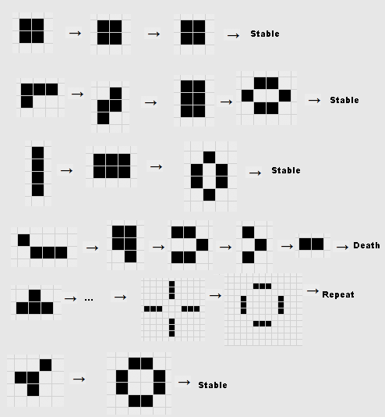

This project investigates something known as cellular automata: we start with a grid of pixels which can be either black or white. We then implement very simply rules which say whether to change the pixel’s colour. This is a simple system for simulating life, for example, bacteria living on a surface. Consider white to be alive and black to be dead. For the “Game of Life” the rules are pretty simple:
- Any live cell with fewer than two live neighbours dies, as if caused by under-population.
- Any live cell with two or three live neighbours lives on to the next generation.
- Any live cell with more than three live neighbours dies, as if by overcrowding.
- Any dead cell with exactly three live neighbours becomes a live cell, as if by reproduction.
The image above shows various starting states and what happens to them: some live, some die, some oscillate, some create “offspring”.
You could use Labview and C together, or perform matrix manipulations within Matlab - and create life on your own computer!

Project 12: Particle Collision Simulator
In this project you will:
- Model atoms as 2D vector particles
- Implement collision rules
- Investigate elastic collisions between particles

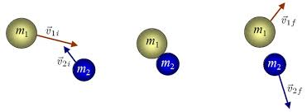

Collisions between particles is central to nuclear physics, and has led to several ground-breaking discoveries, such as finding the Higgs Boson at CERN and using nuclear reactions to generate energy. Collisions can be applied to many other areas of physics, such as car safety testing and producing materials and products that dampen impacts. This project will allow you to simulate 2D elastic collisions between two particles of varying mass and velocity (or the same if you wish). This can be done with LabVIEW, C, or MATLAB although being able to visualise it will make this project easier.

Equations

For this project, you will need to incorporate conservation of momentum and conservation of kinetic energy into your code. Below are some equations to help you calculate their vector positions.

where and are the initial velocities of particles 1 and 2, respectively, and are the final velocities of particles 1 and 2, respectively, m₁ and m₂ are the respective masses of the particles, and x₁ and x₂ are the respective position vectors at the point of collision. The angle brackets represent the dot product of the two vectors inside.
To further extend this project:
- Could you make this a simulation for 3D vectors?
- How would you go about incorporating inelastic collisions into the simulation?
- Can you get one of the particles to fragment (not unlike a neutron firing into an atom of uranium-238)?
- For inelastic collisions, could you plot a graph of the change in kinetic energy over time?

(Author: Cameron Irwin, N0756293)

Project 13: Simulating heat dispersion
In this project you will:
- Simulate many simultaneous random walks
- Use multidimensional arrays and manipulate them
- Calculate temperature before and after equilibrium particles

Quantum cooling is a mechanism which can affect a lot of industrial and physical processes; one up-to-date example of this is in quantum computing. These computers need to keep cool, and to do this they use quantum cooling (click here). Normally when talking about heat, we think of a continuous flow of energy from one body to another, this however is incorrect, as energy is fundamentally quantised. Meaning there is a fundamental minimum unit of energy, that can be used or exchanged, called quantum. In this project you will explore this idea of quantization when it comes to heat and different materials.
To begin with, quanta don’t prefer a certain direction. Their movement is purely random, however when we introduce another object in the system then the number of configurations (entropy) increases, and thus the probability of the hotter object to gain more energy is infinitesimally small. The same applies to the cooler object when losing energy.

In this project we will use 3D arrays and this idea to simulate how atoms exchange quanta with each other, resulting in an apparent “flow” of heat.
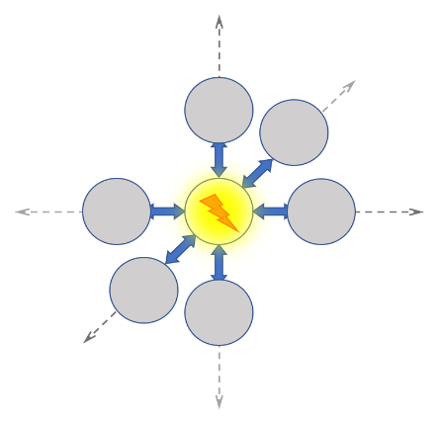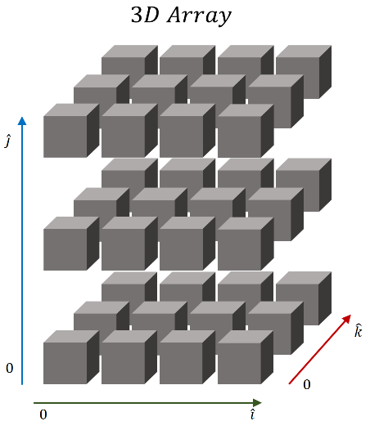
?
Model 2 objects of the same material with 3D arrays and consider the limitations. Set an initial temperature for each of the 2 objects. Calculate the total length of the arrays based on the mass of the objects. Does it matter what value you use? Consider the area of thermal contact and calculate the dimensions of the arrays. Can you use a non-natural value for the total length and dimensions of the array? Define the value of energy that a quantum will have based on how many of them you think will be enough and think about the specific heat capacity of different materials. You will need to use where

: Energy[J], : mass[kg], : specific heat capacity [J/(kg)], : temperature difference [].

Can you think of a way to simulate the random walk of the quanta through the array? You might need a random number generator. The aim of this simulation is to accurately predict how long it takes for materials of different mass and temperatures to reach thermal equilibrium. How do your calculations compare to real life values? Additionally, you could try out some or all of these challenges:

- Can you animate a real-time heat map?
- Could you replace the 3D arrays with 2D arrays or even a 1D arrays?
- Could you include a graph which shows the heat movement as a function of time?

(Author: Petros Oratiou, N0771172)

Project 14: Solar System Simulator
In this project you will:
- Use equations from Astro lectures
- Investigate the solar system
- Find appropriate ways to represent the data
- particles

Throughout the duration of our astronomy lectures we have looked at a multitude of different equations for finding various information about the planets such as their surface temperature, orbital period, solar constant etc. These equations can also be used when modelling the trajectories of satellites, whose operations are critical to many industries worldwide. Below are a few examples of these the equations for orbital period, solar constant and temperature - you may wish to use some of them whilst making the program:

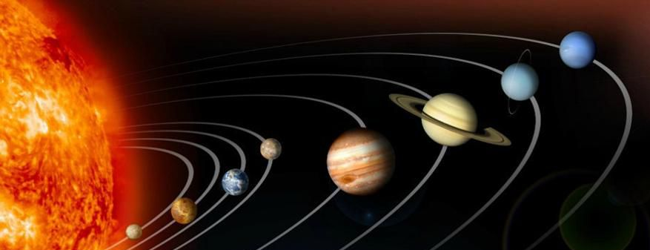
An initial aim of this program could be to show the planets rotating around the sun. You could begin by showing the orbits of the planets and their relative sizes or distance from the sun. How about some images of each planet?

A few others suggestions for things to find/lookup to include in program: angular velocity and frequency; how often will the planets align; finding sidereal days/years; finding escape velocities for the planets etc.

More suggestions:
- You use a drop-down menu to choose a planet for the raw data
- Decide a suitable format to display values in (for example, if their radius from the sun was to scale it probably wouldn’t fit)
- Could you create a theoretical star system and find values for it or allow the user to enter values for relevant data?
- Could you add moons and other objects in orbit around the planets?
Suggestions for testing:
- As it is our own star system many of the values are easy to check
Some values may be slightly off the accepted values, why might this be?

(Author: Kane Hodgkinson, N0733904)

Project 15: MRI Image Processing
In this project you will:
- Load and display images
- Manipulate large datasets
- Investigate image segmentation
- particles

MRI is an imaging technique that provides a 3D representation of an object non-invasively when observing a sample. This 3D representation is composed of a series of 2D images which form virtual slices through the object. The intensity of an individual pixel shows the intensity of the signal from relaxing protons, this intensity will vary by time and material composition.

MRI is used for many applications including medical imaging and research including food for one example. When looking at an object that is composed of many different materials such as the human body being composed of bone, fat and other types of tissues – the scanner operator must identify features in the image based on the layout. This process is prone to human error, so automatic slice-by-slice segmentation may provide a solution to this problem of identifying features in a scan. An example using segmentation on an image to separate apples is shown below, this can then be used as a guide to indicate the size of individual apples.

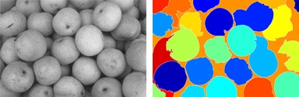

The most basic approach to segmentation, is to look at the histogram of an image and to split the histogram into sections by individual valleys. By then looking at regions of the image that correspond to different sections of the histogram sections, the image can be labelled according to the individual connected sections.

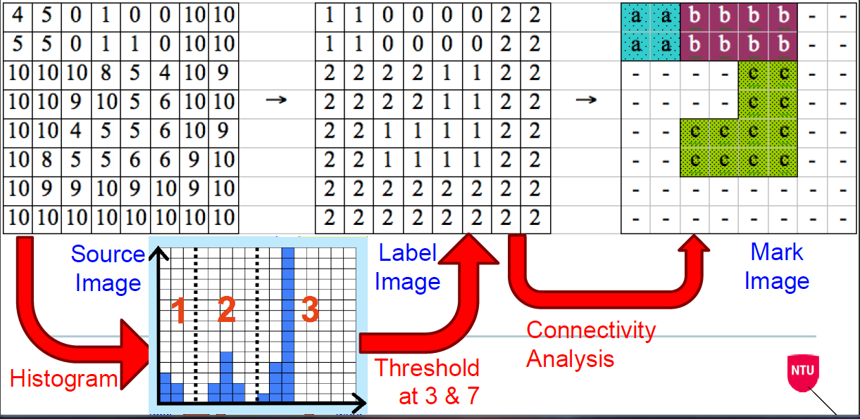
Source: Alan Wood’s Digital Techniques Image Processing

Suggested developments:
3D Segmentation rather than 2D.
Material Identification using relaxation times from multiple datasets

(Author: Ella Mortimer, N0670904)

Project 16: Field Interaction Simulator
In this project you will:
- Calculate how particles move under the influence of fields
- Plot the trajectories of these particles

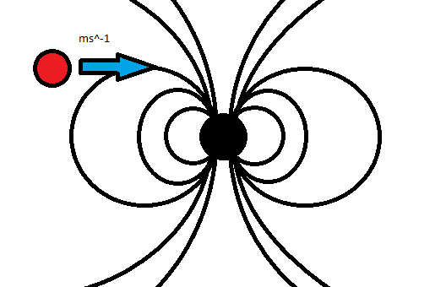

In this project you will create a field simulator to see and image how (electric, magnetic, gravitational) fields bend and exert non-contact force upon bodies, and each other. You will need to factor in kinematics; (e.g. equations of transitional and angular motion, centres of mass), a collisions sandbox of sorts where the end user can draw/apply vectors to objects to simulate situations digitally. The industrial use of this simulator could be to simulate a magnetically levitating train, or show how particles move in a synchrotron.

You might wish to try this project using MatLab. Most if not all mechanics equations can easily be modelled as matrices with this software. The mechanics equations equations below are a good example for this.

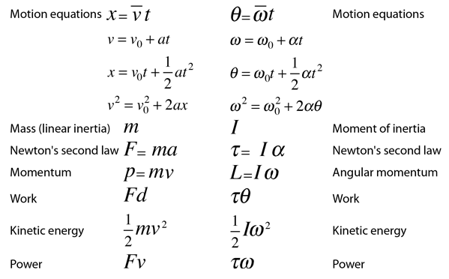

(Author: Sebastian Kilmer, N0775105)

